# INDRODUCTION :

# overview

## I Design a personalized invitation using in this canva .

## That was very easy to use . Anyone to use this canva easier

# Purpose

## My project is creating a personalized invitation .

## I. Create a personalized invitation using in this canva

## 2. Problems Definition & Design Thinking

## 2.1 Empathy map

Kjoijooipi0piphhfhjiggg

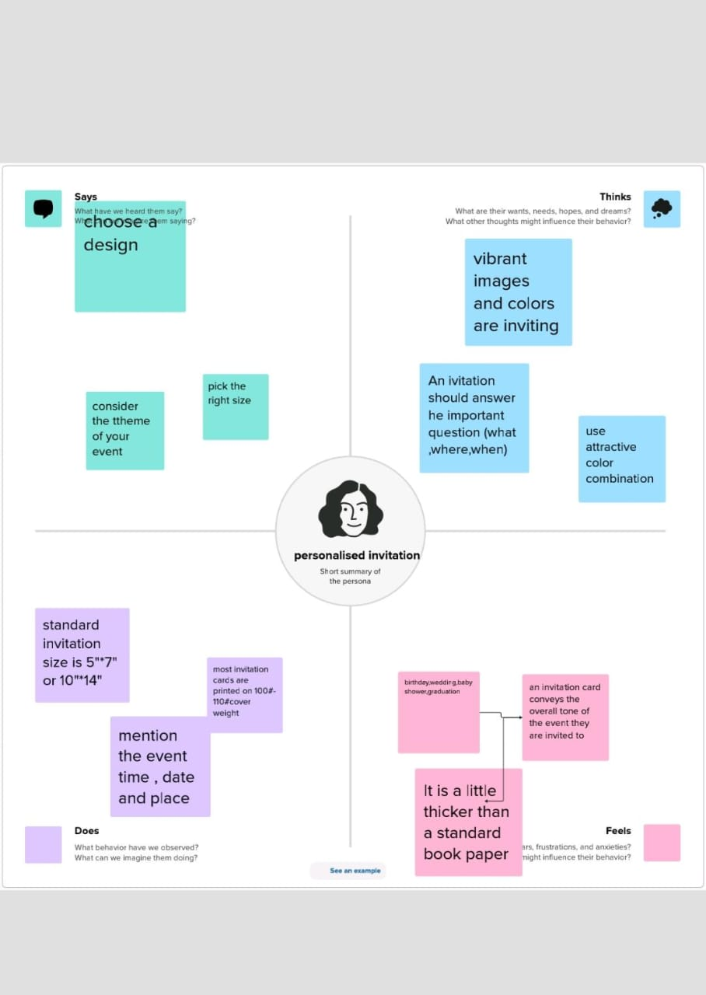

# 2.2 Brain storm and idea prioritization

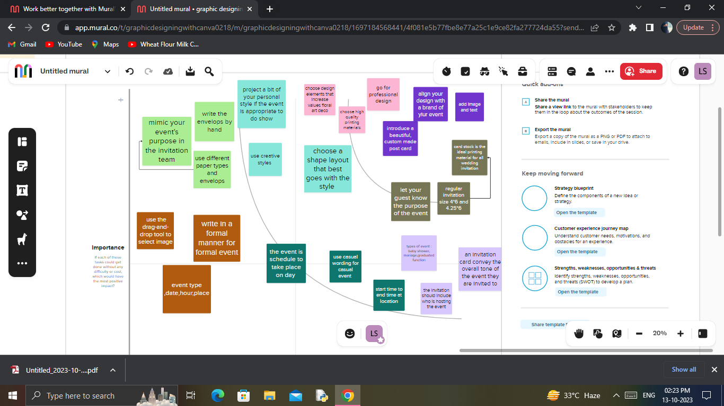

3.Result



# 4 ADVANDAGES

## Easy to using this canva

## Freshers can easy to design anything in this canva

## In this canva has many templates

## Canva was very useful to everyone

# 5. CONCLUSION

## I easily finish my project personalized invitation . canva is the most useful and best app for the freshers . Because , that has many templates that was easy to use